**Configuring IAM**

experimentLabschedule1 houruniversal_currency_alt1 Creditshow_chartIntroductory

infoThis lab may incorporate AI tools to support your learning.

**Overview**

In this lab, you will configure [Identity and Access Management (IAM)](https://cloud.google.com/iam) to grant roles and create custom roles. IAM lets you create and manage permissions for Google Cloud resources. IAM unifies access control for Google Cloud services into a single system and presents a consistent set of operations.

Objectives

In this lab, you will learn how to:

* Use IAM to implement access control.
* Restrict access to specific features or resources.
* Use predefined roles to provide Google Cloud access.
* Create custom IAM roles to provide permissions based on your own job roles.
* Modify custom roles.

**Setup and requirements**

For each lab, you get a new Google Cloud project and set of resources for a fixed time at no cost.

1. Sign in to Qwiklabs using an **incognito window**.
2. Note the lab's access time (for example, 1:15:00), and make sure you can finish within that time.  
   There is no pause feature. You can restart if needed, but you have to start at the beginning.
3. When ready, click **Start lab**.
4. Note your lab credentials (**Username** and **Password**). You will use them to sign in to the Google Cloud Console.
5. Click **Open Google Console**.
6. Click **Use another account** and copy/paste credentials for **this** lab into the prompts.  
   If you use other credentials, you'll receive errors or **incur charges**.
7. Accept the terms and skip the recovery resource page.

**Note:** Do not click **End Lab** unless you have finished the lab or want to restart it. This clears your work and removes the project.

**Task 1. Sign in with two user accounts**

In this task, you sign in using two different user accounts. These accounts are used later in the lab to explore IAM access to specific resources.

Sign in to the Google Cloud Console as the first user

For this lab, Qwiklabs has provisioned you with two user names available in the **Connection Details** dialog.

1. Use a Chrome incognito window and sign in to the [Cloud Console](https://console.cloud.google.com/) with the **Username 1** provided in Qwiklabs. Note that both usernames use the same password.
2. Accept the Terms and Conditions for your temporary Google account.
3. Because this is a temporary account, do not add recovery option data or sign up for free trials.
4. When prompted, accept the Terms and Conditions for Google Cloud.

Sign in to the Cloud Console as the second user

1. Open another browser tab in your incognito window.
2. Browse to the [Cloud Console](https://console.cloud.google.com/).
3. Click on the user icon in the top-right corner of the screen, and then click **Add account**.
4. Sign in to the Cloud Console with the **Username 2** provided in Qwiklabs.

**Note:**At some points in this lab, if you sign out of the **Username 1** account, the **Username 2**account is deleted by Qwiklabs. So be sure to remain signed in to **Username 1**.

**Task 2. Explore current roles in the IAM console**

In this task, you explore the current roles for Username 1 and Username 2.

Navigate to the IAM console and explore roles

Make sure you are on the **Username 1** Cloud Console tab.

1. To view the **IAM** console, in the **Navigation menu**, click **IAM & admin > IAM**.
2. In the IAM console, locate the line for **Username 1**. Note that Username 1 has a few roles, including Project **Owner**.
3. Locate the line for **Username 2**. Note that Username 2 has a Project **Viewer** role.

**Note:**In the next three steps, be sure **NOT** to change any of the permissions. You will use the edit feature just to view the roles assigned.

1. Click the Edit principal button Edit icon on the line for **Username 2**.
2. Click **Viewer** to expand the list of possible roles. Do not change any of the roles yet, but you do have permissions to do so because Username 1 is project owner.
3. Click outside the role list to collapse it, and then click **Cancel**.
4. Switch to the Cloud Console tab for **Username 2**.
5. On the **Navigation menu**, click **IAM & admin > IAM**.
6. Click the Edit principal button Edit icon on the line for **Username 2**. You will not be able to edit the role. **Username 2** currently has access to view the project (Project Viewer), but does not have permissions to change anything.

**Task 3. Prepare a resource for access testing**

In this task, you create a Cloud Storage bucket and a sample text file. You test access to the sample file using Username 2.

Create a bucket and upload a sample file

1. Switch to the **Username 1** Cloud Console tab.
2. On the Google Cloud Console title bar, click **Activate Cloud Shell** (Activate Cloud Shell icon). If prompted, click **Continue**.
3. Run the following command to create a new storage bucket in us-central1:

gcloud storage buckets create -l us-central1 gs://$DEVSHELL_PROJECT_ID

Copied!

content_copy

1. Run the following command to create a sample text file in your Cloud Shell:

echo "this is a sample file" > sample.txt

Copied!

content_copy

1. Run the following command to copy the file to the bucket just created:

gcloud storage cp sample.txt gs://$DEVSHELL_PROJECT_ID

Copied!

content_copy

Click *Check my progress* to verify the objective.

Prepare a resource for access testing

Check my progress

Verify the Project Viewer role access

1. Switch to the **Username 2** Cloud Console tab.
2. Click **Activate Cloud Shell** (Activate Cloud Shell icon) to open Cloud Shell. If prompted, click **Continue**.
3. Run the following command to verify that **Username 2** can view the file in the bucket:

gcloud storage ls gs://$DEVSHELL_PROJECT_ID

Copied!

content_copy

1. Run the following commands to create a file and try to upload it to the bucket:

echo "this is another file" > sample2.txt

gcloud storage cp sample2.txt gs://$DEVSHELL_PROJECT_ID

Copied!

content_copy

Username 2 cannot upload the file to Cloud Storage because it only has the Project Viewer role.

**Output:**

Copying file://sample2.txt

ERROR: User xxx does not have permission to access b instance (or it may not exist): student-xx-xxxx@qwiklabs.net does not have storage.objects.create access to the Google Cloud Storage object.

**Task 4. Remove project access**

In this task, you remove the Project Viewer role for Username 2. You verify that Username 2 has lost access to the Cloud Storage bucket.

Remove the Project Viewer role for Username 2

1. Switch to the **Username 1** Cloud Console tab.
2. On the **Navigation menu**, click **IAM & admin > IAM**.
3. For **Username 2**, click on the pencil icon edit (Edit icon) button.
4. Click the delete icon next to the assigned role.
5. Click on **Save**.

Notice that the user has disappeared from the list! The user has no access now. Username 2 still has a Google Cloud account, but has no access to the project.

Verify that Username 2 has lost access

1. Switch to the **Username 2** Cloud Console tab.
2. Run the following command in Cloud Shell to verify that **Username 2** can no longer view the file in the bucket:

gcloud storage ls gs://$DEVSHELL_PROJECT_ID

Copied!

content_copy

**Output:**

ERROR: User xxx does not have permission to access b instance (or it may not exist): student-xx-xxxx@qwiklabs.net does not have storage.objects.list access to the Google Cloud Storage bucket.

1. If you can still see the file, the access change has not taken effect yet. Wait a minute and try the command again until you see Permission denied on resource .
2. From the **Username 2** console, try to access the Compute Engine service. On the **Navigation menu**, click **Compute Engine > VM instances**. You will not even be able to view the Compute Engine dashboard.

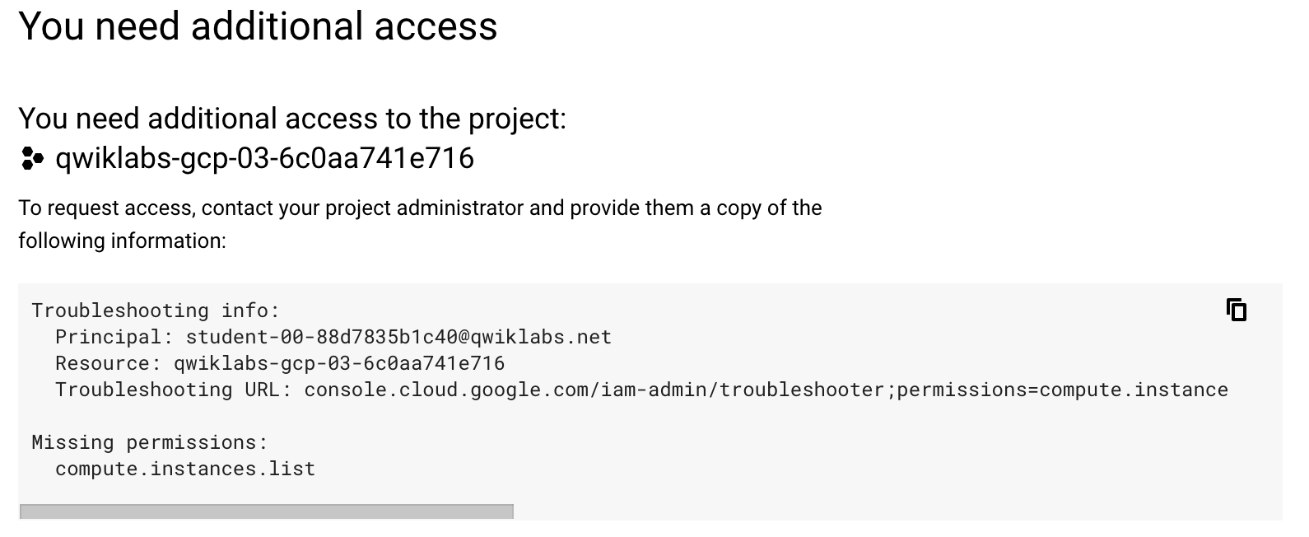

**Note: Username 2** still has a Google Cloud account, but has no access to the project from either the Cloud Console or the CLI.

**Task 5. Add storage access**

In this task, you add storage object viewer permissions for Username 2 and verify that the user can view the contents of the Cloud Storage bucket.

Add storage object viewer only permissions for Username 2

1. Copy the value of **Username 2** from the Qwiklabs **Connection Details** dialog.
2. Switch to the **Username 1** Cloud Console tab.
3. On the **Navigation menu**, click **IAM & admin > IAM**.
4. Click **GRANT ACCESS** to add a user.
5. For **New principals**, paste the **Username 2** value you copied from the Qwiklabs **Connection Details** dialog.

In the next step, you will use a predefined role to give Storage Object Viewer permissions to Username 2. Feel free to explore the available predefined roles.

1. For **Select a role**, select **Cloud Storage > Storage Object Viewer**.
2. Click **Save**.

Verify that Username 2 has storage access

1. Switch to the **Username 2** Cloud Console tab.

**Note: Username 2** doesn't have the Project Viewer role, so the user still can't see the project or any of its resources in the Cloud Console. For example, Username 2 still cannot view the Compute Engine dashboard. However, Username 2 has specific access to view Cloud Storage and can make API calls to view storage.

1. Run the following command in Cloud Shell to view the contents of the bucket you created earlier:

gcloud storage ls gs://$DEVSHELL_PROJECT_ID

Copied!

content_copy

As you can see, **Username 2** now has limited access to view Cloud Storage.

**Task 6. Create custom roles**

In this task, you create a custom role for a job role of Privacy Reviewer. This role performs data privacy reviews and needs permissions to view data in various different services, such as Cloud Storage, Cloud Bigtable, and Cloud Spanner

Google Cloud also allows for the creation of custom roles. Custom roles can be used to map your organization's specific job roles to Google Cloud permissions. A custom role can combine permissions from multiple Google Cloud services into one role and then share that new role across your entire organization.

**Note:**Generally it is better to use predefined roles first, because they are managed by Google. Creating and using custom roles allows for specific permissions to be set, but add operational overhead because they must be manually managed.

Custom roles can also be created based on an existing predefined role. However, if the predefined role that your custom role is based on changes after you create your custom role, those changes are not inherited by the custom role.

To create a custom role, a caller must possess the iam.roles.createpermission. By default, the owner of a project or an organization has this permission and can create and manage custom roles. In this lab, Username 1 is a project owner.

Create a custom role using the Cloud Console

1. Switch to the **Username 1** Cloud Console tab.
2. On the **Navigation menu**, click **IAM & admin > Roles**. This page currently displays all the predefined roles. Notice that there are many of them (there are several hundred pages of them).
3. Click **Create Role**.
4. Use the following values for the Role properties:

|  |  |  |  |
| --- | --- | --- | --- |
| **Title** | **Description** | **ID** | **Role launch stage** |
| Privacy Reviewer | Custom role to perform data reviews | privacyreviewer | Alpha |

Each of the placeholder values is described below:

* **Title** is a friendly title for the role, such as "Role Viewer."
* **Description** is a short description about the role, such as "My custom role description."
* **ID** must be unique.
* **Role launch stage** indicates the stage of a role in the launch lifecycle, such as Alpha, Beta, GA, or Disabled.

1. Click **Add permissions**.
2. In the **Filter** field, type storage, and then press **Enter**.
3. Select **storage.buckets.list**, **storage.objects.list**, and **storage.objects.get**, and then click **Add**. 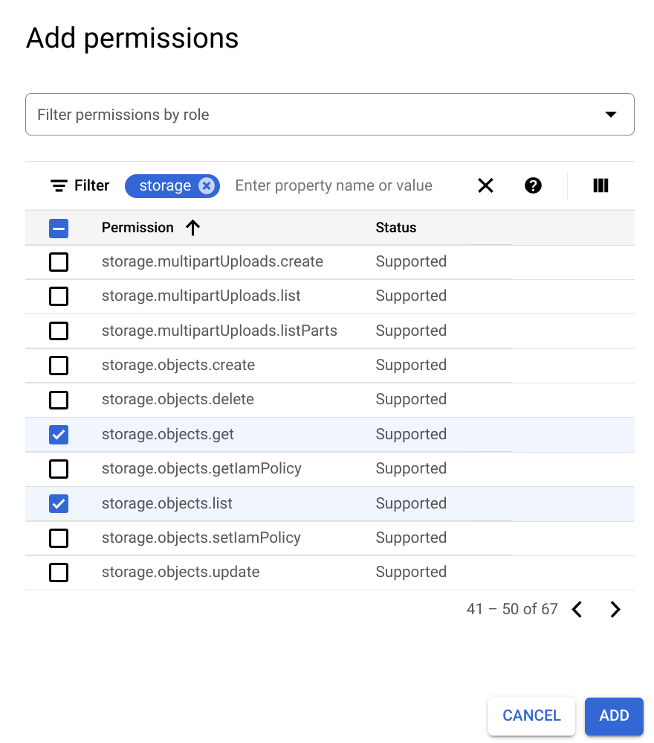

**Note:**To add required permissions you may need to see next pages.

1. Click **Add permissions** again.
2. In the **Filter** field, type spanner, and then press **Enter**.
3. Select **spanner.databases.get** and **spanner.databases.list**, and then click **Add**.
4. Click **Add permissions** again.
5. In the **Filter** field, type bigtable, and then press **Enter**.
6. Select **bigtable.tables.get**, **bigtable.tables.list**, and **bigtable.tables.readRows**, and then click **Add**.

Your permissions should look like this:

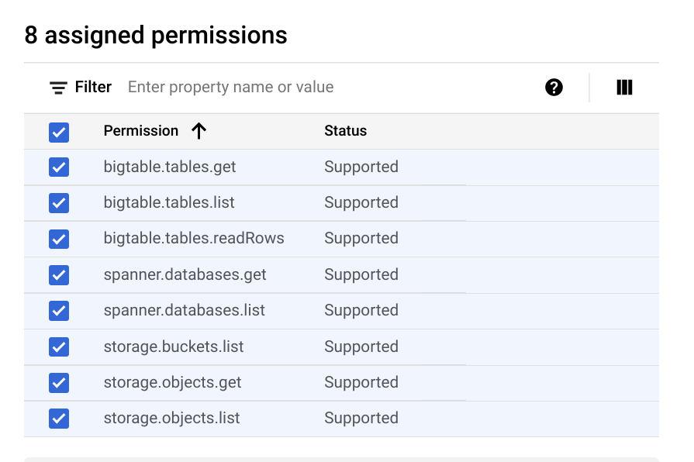

1. Click **Create**.

Your new custom role should now be displayed at the top of the Roles table.

Create a custom role using the CLI and YAML file

* Roles can also be created using the CLI and a YAML file. The YAML file contains the role definition and is in the form:

title: [ROLE_TITLE]

description: [ROLE_DESCRIPTION]

stage: [LAUNCH_STAGE]

includedPermissions:

- [PERMISSION_1]

- [PERMISSION_2]

Copied!

content_copy

* So the YAML for the role you just created in the Cloud Console would look like:

title: Privacy Reviewer

description: Custom role to perform data reviews

stage: ALPHA

includedPermissions:

- storage.buckets.list

- storage.objects.list

- storage.objects.get

- spanner.databases.get- spanner.databases.list

- bigtable.tables.get

- bigtable.tables.list

- bigtable.tables.readRows

Copied!

content_copy

Do not copy the YAML file above; you will create a different role using the CLI.

1. Verify that you are still on the browser tab for **Username 1**, and open Cloud Shell if it is not already open.
2. To create a new file called **role.yaml**, run the following command:

nano role.yaml

Copied!

content_copy

1. Copy the following role definition and paste into the nano editor in Cloud Shell:

title: App Viewer

description: Custom role to view apps

stage: ALPHA

includedPermissions:

- compute.instances.get

- compute.instances.list

- appengine.versions.get

- appengine.versions.list

Copied!

content_copy

1. Press **CTRL+X,** press **Y**, and then press **Enter** to save the file.
2. To create a new role, run the following command:

gcloud iam roles create app_viewer --project \

$DEVSHELL_PROJECT_ID --file role.yaml

Copied!

content_copy

You will see the following output.

**Output:**

Created role [app_viewer].

description: Custom role to view apps

etag: BwVshqVuvBs=

includedPermissions:

- appengine.versions.get

- appengine.versions.list

- compute.instances.get

- compute.instances.list

name: projects/xxxxxxxxxx/roles/app_viewer

stage: ALPHA

title: App Viewer

1. To list all the custom roles in your project, run the following command:

gcloud iam roles list --project $DEVSHELL_PROJECT_ID

Copied!

content_copy

You will see both roles you created.

Click *Check my progress* to verify the objective.

Create custom roles

Check my progress

**Task 7. Use a custom role**

In this task, you create a custom role and assign it to Username 2.

1. Make sure you are on the **Username 1** Cloud Console tab.
2. On the **Navigation menu**, click **IAM & admin > IAM**.
3. In the IAM console, locate the line for **Username 2** and click the Edit principal (Edit icon) button. **Username 2** should currently have the **Storage Object Viewer** role.
4. Click **Add another role**, and then click **Select a role**.
5. In the **Custom** category, select one of the roles you just created.
6. Click **Save**.

You have assigned **Username 2** to one of your custom roles.

**Task 8. Maintain custom roles**

In this task, you modify, disable, delete, and un-delete a custom role.

When using custom roles, it's important to track what permissions are associated with the roles you create, because available permissions for Google Cloud services evolve and change over time. Unlike Google Cloud predefined roles, you control if and when permissions are added or removed.

Modify role permissions

To modify an existing role, you need to first get the role's definition, update the definition, and then update the role.

1. Make sure you are on the **Username 1** Cloud Console tab.
2. To retrieve the **app_viewer** role's definition, run the following command in Cloud Shell:

gcloud iam roles describe app_viewer --project \

$DEVSHELL_PROJECT_ID

Copied!

content_copy

The describe command returns the following output.

**Output:**

description: Custom role to view apps

etag: [Etag value]

includedPermissions:

- appengine.versions.get

- appengine.versions.list

- compute.instances.get

- compute.instances.list

name: projects/[Project_ID]/roles/app_viewer

stage: DISABLED

title: App Viewer

1. Copy the output from your describe command. Be sure to copy from the description line to the title line.
2. Run the following command to create a new YAML file:

nano update-role.yaml

Copied!

content_copy

1. Paste the output from the describe command into the nano editor.
2. Add the following two lines just below the includedPermissions: lines:

- container.clusters.get

- container.clusters.list

Copied!

content_copy

1. Press **CTRL+X,** press **Y**, and then press **Enter** to save the file.
2. To update the **app_viewer** role, run the following command:

gcloud iam roles update app_viewer --project \

$DEVSHELL_PROJECT_ID --file update-role.yaml

Copied!

content_copy

The **app_viewer** role has been updated and two permissions were added.

Click *Check my progress* to verify the objective.

Modify role permissions

Check my progress

Disable a role

You can disable a custom role. When a role is disabled, any policy bindings related to the role are inactivated, which means that the permissions in the role will not be granted, even if you grant the role to a user.

1. Make sure you are on the **Username 1** Cloud Console tab.
2. To disable the **app_viewer** role created earlier in this lab, run the following command in Cloud Shell:

gcloud iam roles update app_viewer --project \

$DEVSHELL_PROJECT_ID --stage DISABLED

Copied!

content_copy

Delete a role

Roles that are deleted are suspended and cannot be used to create new IAM policy bindings. After the role has been deleted, existing bindings remain, but are inactive. The role can be un-deleted within seven days. After seven days, the role enters a permanent deletion process that lasts 30 days.

1. Make sure you are on the **Username 1** Cloud Console tab.
2. To delete the **app_viewer** role created earlier in this lab, run the following command in Cloud Shell:

gcloud iam roles delete app_viewer --project \

$DEVSHELL_PROJECT_ID

Copied!

content_copy

1. To list all the roles in the project, run the following command:

gcloud iam roles list --project $DEVSHELL_PROJECT_ID

Copied!

content_copy

Notice that the deleted **app_viewer** role is no longer listed.

1. To list all the roles in the project including the deleted roles, run the following command:

gcloud iam roles list --project $DEVSHELL_PROJECT_ID \

--show-deleted

Copied!

content_copy

Un-delete a role

Role can be un-deleted within seven days of being deleted.

1. To un-delete the **app_viewer** role, run the following command in Cloud Shell:

gcloud iam roles undelete app_viewer --project \

$DEVSHELL_PROJECT_ID

Copied!

content_copy

1. To list all the roles in the project, run the following command:

gcloud iam roles list --project $DEVSHELL_PROJECT_ID

Copied!

content_copy

Notice that the **app_viewer** role is listed again.

**Review**

In this lab, you did the following:

1. Used IAM to implement access control.
2. Restricted access to specific features or resources.
3. Used predefined roles to provide Google Cloud access.
4. Created custom IAM roles to provide permissions based on your own job roles.
5. Modified custom roles.

**End your lab**

When you have completed your lab, click **End Lab**. Google Cloud Skills Boost removes the resources you’ve used and cleans the account for you.

You will be given an opportunity to rate the lab experience. Select the applicable number of stars, type a comment, and then click **Submit**.

The number of stars indicates the following:

* 1 star = Very dissatisfied
* 2 stars = Dissatisfied
* 3 stars = Neutral
* 4 stars = Satisfied
* 5 stars = Very satisfied

You can close the dialog box if you don't want to provide feedback.

For feedback, suggestions, or corrections, please use the **Support** tab.

Copyright 2022 Google LLC All rights reserved. Google and the Google logo are trademarks of Google LLC. All other company and product names may be trademarks of the respective companies with which they are associated.